Screenshots

VBA window with 3 Modules

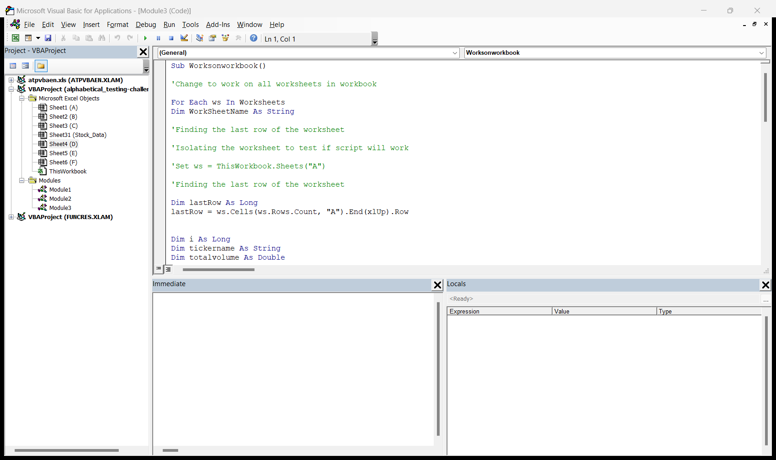

Module 1 shows a combination of all worksheets into one summary sheet

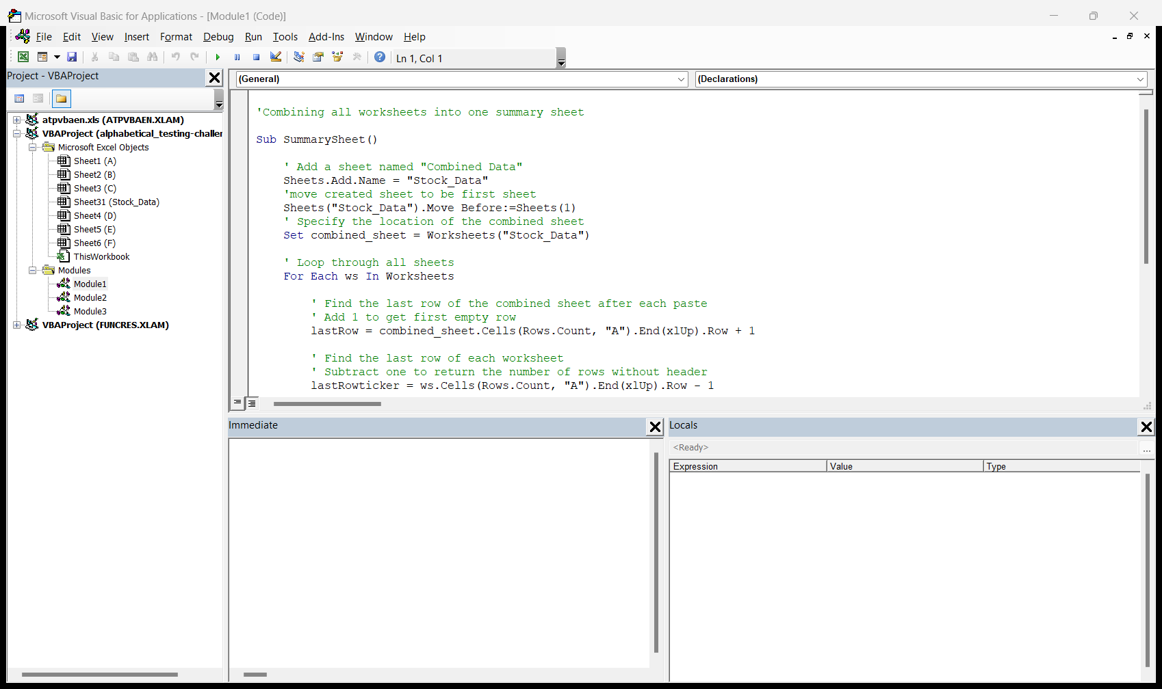

Module 2 – shows script running only on one worksheet

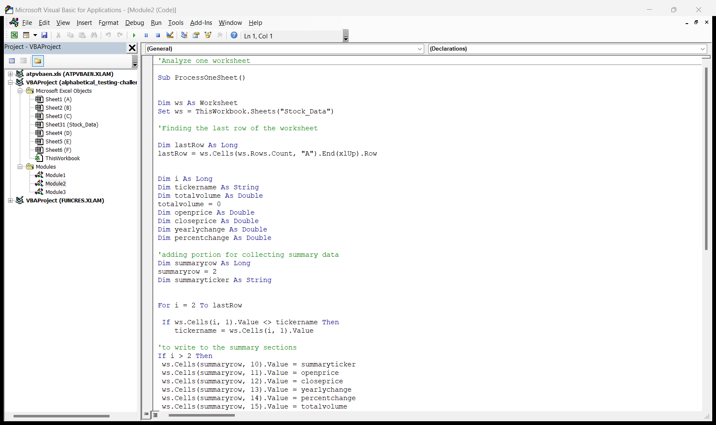

Results of Modules 1 and 2 in which all stocks were combined and each ticker summarized on the same worksheet

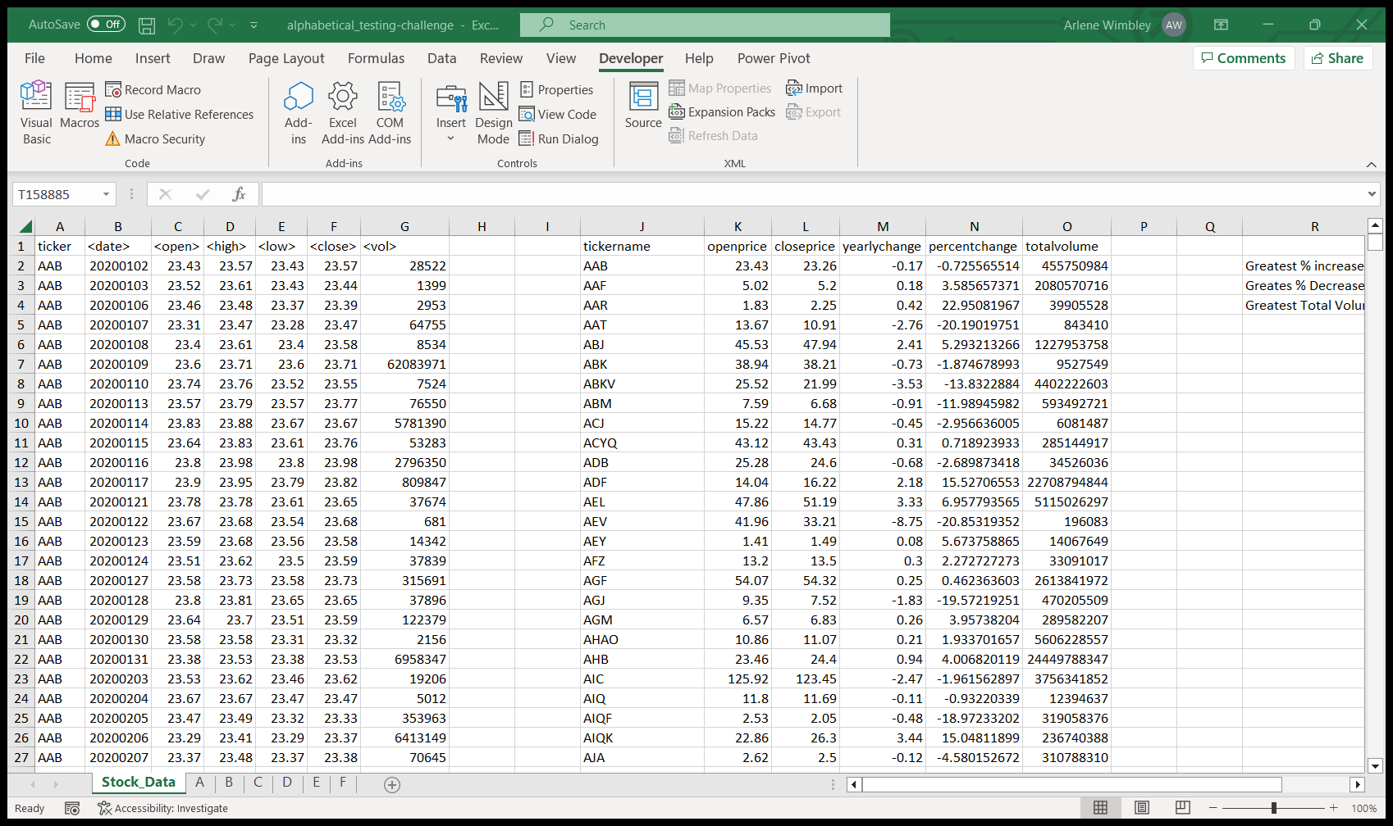

Module 3 shows that the script that works on one sheet, now works on all sheets in workbook

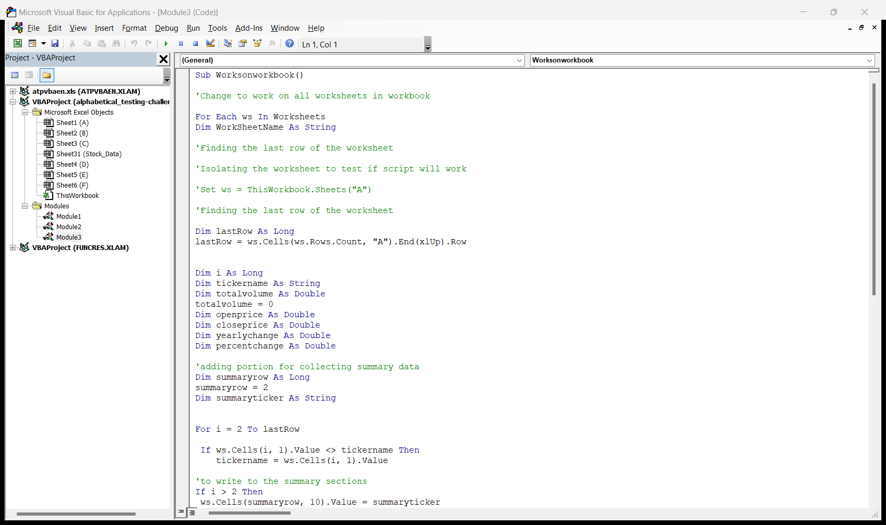

Results of Module 3 – shows stock summarized on individual sheets

